Object Complement

✅ What Is an Object Complement?
# Source: AI Source: Provided by: [Data Path: Persons Table -> ID Column: 1, Name_En Column: Motasem Essam] -> From: [ChatGPT] on [8/4/2025]
An Object Complement is a word or phrase that follows and modifies or renames the direct object of a verb.
It tells us what the object has become, what it is, or how it is described as a result of the action.

🔸 Key Features:
# Source: AI Source: Provided by: [Data Path: Persons Table -> ID Column: 1, Name_En Column: Motasem Essam] -> From: [ChatGPT] on [8/4/2025]
- Follows a direct object
- Describes or renames that direct object
- Typically a noun, pronoun, or adjective
- Appears with certain transitive verbs like:
make, name, elect, call, find, consider, paint, choose

🔸 Common Structure:
# Source: AI Source: Provided by: [Data Path: Persons Table -> ID Column: 1, Name_En Column: Motasem Essam] -> From: [ChatGPT] on [8/4/2025]
Subject + Verb + Direct Object + Object Complement

🔸 Examples in Sentences:
# Source: AI Source: Provided by: [Data Path: Persons Table -> ID Column: 1, Name_En Column: Motasem Essam] -> From: [ChatGPT] on [8/4/2025]
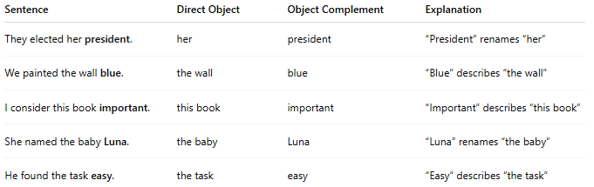
Sentence | Direct Object | Object Complement | Explanation
They elected her president. | her | president | “President” renames “her”
We painted the wall blue. | the wall | blue | “Blue” describes “the wall”
I consider this book important. | this book | important | “Important” describes “this book”
She named the baby Luna. | the baby | Luna | “Luna” renames “the baby”
He found the task easy. | the task | easy | “Easy” describes “the task”

🔸 How to Identify an Object Complement:
# Source: AI Source: Provided by: [Data Path: Persons Table -> ID Column: 1, Name_En Column: Motasem Essam] -> From: [ChatGPT] on [8/4/2025]
- Find the direct object.
- Check if the word after it describes or renames that object.
- Try rephrasing: [Direct Object] is/was [Complement]
  - “The wall is blue.” ✅ → object complement

